**Our Energy Future**

**Energy and Modern Agriculture – Part 1**

**Brief Introduction to Innovations in Agriculture**

Below are a few of the most impactful innovations in human history:

* Plant and animal domestications

Prior to agriculture, which emerged in nine separate areas across four continents between 8500 BC and 2500 BC the world’s human population was stable at 1 million people from 70,000 BC to 8000 BC. Civilization as we know it arose from the leisure time that arose from the development of agriculture as people pursued other crafts like manufacturing, toolmaking and domestication of animals.

14 of the 148 species of large mammalian herbivores were domesticated for use in agriculture, while 100 of 200,000 species of higher plants yield agronomic products

* Irrigation

Developed alongside or potentially right after agriculture. Evidence of irrigation exists in Egypt and Mesopotamia from 6000 BS. Today, there are 284 million hectares of irrigated land in the world (as of 1998).

* Birth of Industrial Agriculture (mid-1500s to mid-1800s)

All non-mechanized tools that allowed people to expend less energy planting and harvesting, thus producing more foos. The seed drill (1701), plough (1730) and thresher (1786) all were important inventions during this time which allowed the average number of bushels per acre produced on farmland to increase from ~10 in 1550 to over 30 in 1860.

* Machines running off fossil fuels replace mammalian / human labor (mid-1800s to early 1900s)

In 1830, it took about 250 labor hours to produce 100 bushels of wheat. By 1955, it took 6 hours. With the shift to fossil-fueled engines after WWI coupled food prices to fuel prices

* Chemical fertilizers, specifically nitrogen, phosphorous and potassium (early 1900s to today)

*Nitrogen:* Promotes leaf growth, protein synthesis and chlorophyll formation

*Phosphorous:* Promotes root, flower and fruit development

*Potassium:* Promotes stem and root growth, along with protein synthesis

Chemical fertilizers enabled an increase in crop intensity; the only fertilizer that was available before this time was manure from animals. This further coupled fuel prices with food prices as much of fertilizer production was based of usage of machines powered by fossil fuels.

* Green Revolution (1943 – 1960s)

This entailed the introduction of modern farming techniques and higher-yielding, pest-resistant varieties of crops to significantly increase crop production. Norman Borlaug was the originator of the Green Revolution, starting in Mexico in 1943, and eventually won the Nobel Peace Prize in 1970.

The Green Revolution also impacted the efficiencies of animal food production, enabling a shorter time span to bring animals to market.

As illustrated by the graphs below, these techniques had an extraordinary impact, causing the amount of various crops produced to increase dramatically while the price of each crop dropped. This techniques and technologies demonstrated a reverse trend apparent in chemical fertilization / mechanization of agriculture which *decoupled* the price of food and fuel.

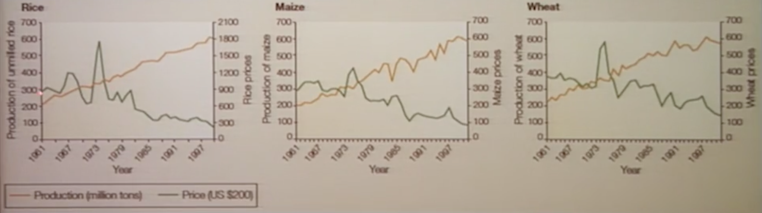However, since the 1990s (which represent the end of the graphs below), the coupling of the price of food and fuel has reversed this trend lower crop prices.

* Crop Protection (Herbicides, Insecticides, and Fungicides)

There were techniques to protect crops going back to the dawn of agriculture, but these were natural ingredients like salt. In decades past, things like dichlorodiphenyltrichloroethane (DDT) and toxic arsenic and hydrogen cyanides were employed on crops but have since been outlawed.

The types of crop protection employed today include things like organophosphate insecticides and acidic herbicides. As the production of these chemicals rely on machinery that run on fossil fuels, crop protection enhances the coupling of the price of food and fuel

**Benefits of these innovations on society**

* Percentage of income spent on food has dropped

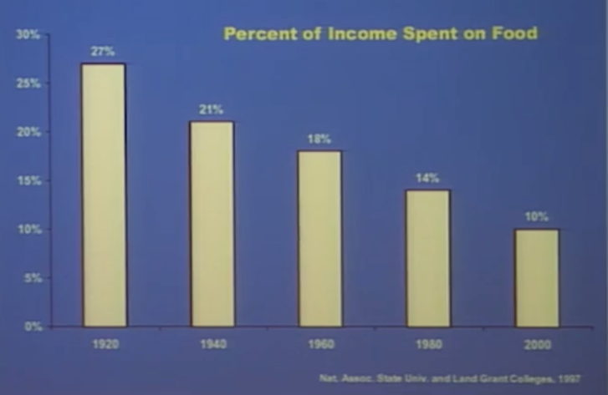The combination of these forces have been tremendously successful in providing affordable and safe food to people all over the globe. The percent of income spent on food decreased dramatically over the course of the 20th century; in the United States it dropped from 27% in 1920 to 6% in 2006.

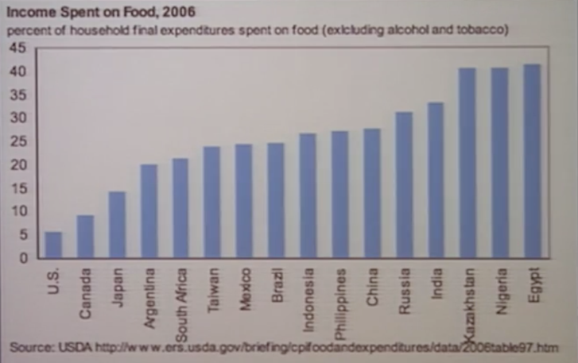While the percentage of income spent on food is higher in other parts of the world, the percentage has dropped universally. That being said, in some parts of the world this percentage remains high, with nearly 50% of income going to food for the populations of Egypt, Nigeria and Kazakhstan.

* Seasonal produce is no longer seasonal

Almost anywhere in the world, the agriculture industry has extended the availability of so-called “seasonal” crops in both space (all over the globe) and time (year-round). This access is enabled by transportation, which is highly dependent on fossil fuels, thus exacerbating the trend of coupling food and fuel prices

**Biofuels**

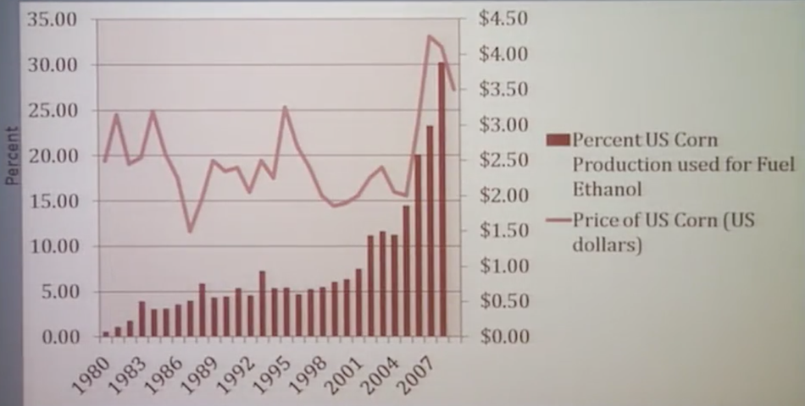Another trend which has furthered the coupling of food and fuel prices is biofuels. In other words, crops like corn are not only used as food, but also fuel.

While there are a lot of good reasons to use biofuels, one of the consequences is that the crop is sold to the market which will pay the highest price for it, causing that price to go up.

**Energy and Modern Agriculture – Part 1**

|  |  |  |
| --- | --- | --- |
| Food | Energy (kWh) to produce 1 lb. | Avg. M3 water to produce 1 ton |
| Corn | 0.43 | 1020 |
| Milk | 0.75 | 738 |
| Apples | 1.67 |  |
| Eggs | 4 | 3519 |
| Chicken | 4.4 | 3809 |
| Cheese | 6.75 | 5288 |
| Pork | 12.6 | 5,469 |
| Beef | 31.5 | 16,726 |
| Potatoes |  | 133 |
| Wheat |  | 1437 |
| Soybeans |  | 2517 |
| Rice |  | 2552 |

**Coupling of food and fuel prices**

One thing that can be done to affect the amount of energy used in food and agriculture are gains in efficiency. Different types of food require different amounts of energy in order to be produced. The table show common foods and the average amount of energy required to produce one pound of the particular food, along with the amount of water (in cubic meters) to produce a ton of each food.

These are just a couple layers to consider when figuring out the amount of resources needed to produce food. Not all food require the same resources to produce, and not all food gives you the same energy when you eat it.

Depending on how we choose to eat and the resource intensity of that food, we can enhance or diminish the coupling of food and fuel prices.

The table only depicts the amount of energy/water needed to produce a given food, but there are other energy demands needed to get food into the hands of humans, including:

* Food processing
* Food transportation

Regarding food transportation, buying local can be a very good thing in regards to saving on the amount of energy needed to transport food, but if the growing of the food requires a lot more energy (e.g., warm weather crops when you live in a cold climate), these transportation energy savings are more than offset by the energy demands of producing the food in the first place.

In summary, the below consequences have contributed to the coupling of food and fuel prices:

* Fertlizers
* Crop protection chemicals
* 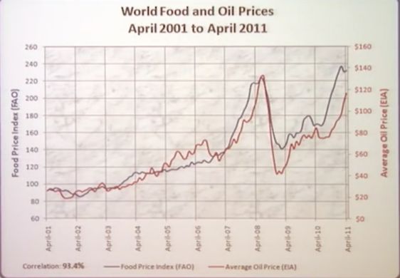Year-round availability
* Global distribution
* Dual use of crop as food and fuel
* Meat-based diets

The coupling of food/fuel prices isn’t necessarily a bad thing, but can become dangerous when fuel prices rise dramatically. Which is what has happened in the past 10+ years, with a 93.4% correlation between food and oil prices as demonstrated by the graph on the right.

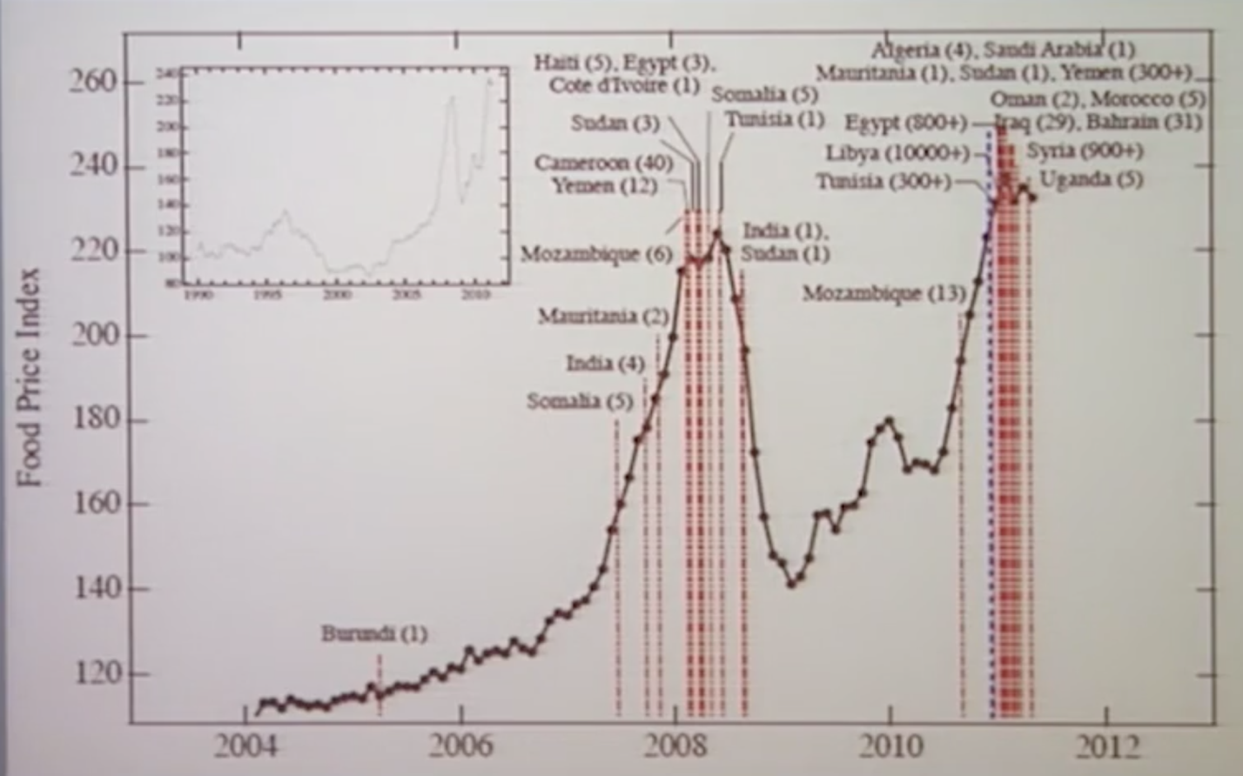Food price spikes caused by fuel price spikes can have tremendous consequences for society. The graph shows the food riots which occurred throughout the world (mostly in Africa and Arab countries) coincident with the rise in the food price index, which in turn is coincident with fuel prices.

**Decoupling food and fuel prices**

There are innovations which have the ability to decouple food and fuel prices.

*Genetic Engineering (GE)*

This extends the work that Norman Borlaug did to cause the Green Revolution. GE was made useful in 2013 by the World Food Prize recipients Marc Van Montagu, Mary-Dell Chilton, and Robert T Fraley, and involves transferring genes from bacteria into plants. This causes the plants themselves to demonstrate traits like insect resistance, thereby limiting/eliminating the need for chemicals and enabling more food production per unit fuel.

*Precision Agriculture*

This is an umbrella term that refers to all the things that are going on in farms across the world that use high-tech tools for site-specific crop management. Tasks that fall under precision agriculture include:

* GPS sensors on tractors/vehicles which measure things like soil moisture at different locations on an individual’s farm. With this data, farmers:
  + Apply fertilizer in different amounts to get soil at optimal state for yield
  + Use different varieties/densities of seed at targeted areas of the farm
* During harvest, have sensors which track the yield on a square-foot basis

These practices have been employed for 10-20 years and is extremely common in more developed countries like the US, and contributes to the decoupling of food and fuel prices

*Environmental Footprint Label*

This is a theoretical innovation that hasn’t been implemented yet, but this involves something in the marketplace that would allow consumers to decouple food and fuel prices. This label would provide transparency to the consumer on what resources went into production and distribution of the food they buy. It would incorporate some/all of the following aspects:

* Fuel: Number of passes by the tractor over the field
* Fertilizer: Number of pounds per acre
* Water: number of inches of irrigation
* Land: Number of acres per ton of harvest